Kings Corner Surgery

Welcome to our Kings Corner Surgery (KCS) Summer Update 2021
The PPG (Patient Participation Group) would like to thank all of the team at KCS for their unwavering support during what has been a very challenging time. Each and every team member has worked way beyond the call of duty to keep us, where possible, safe and well.

Content:
- Patient Frustration & Challenging times
- What has caused Patient Frustration
- What the surgery are doing to address patient feedback
- e-consults
- Range of Clinics available
- Where to go when feeling unwell

Patient Frustration & Challenging times – Apology & Explanation
An apology and explanation from the team at Kings Corner Surgery to any Patients who have been/are disappointed with us as a surgery or a profession, or who may become so in the future.
Over the last 12 months, General Practice has undergone considerable adjustment in response to COVID-19, with the way patients access their GP and other healthcare professionals to balance both remote and safe face to face consultations.
At times you may have experienced GP’s being difficult to speak to or see in person. We are sorry if this has happened to you. Sadly, the cause is something that neither patients or GP’s are in control of and it is eroding the relationship between us nationally. The pandemic has resulted in all GP surgeries having to adapt to new procedures and processes to keep all patients and staff safe which has sadly resulted in face to face appointments being reduced significantly and the ‘human touch’ at times just not possible.

What has caused Patient Frustration?
What we, as a surgery, are expected to achieve has increased far beyond funding and staffing, year on year, for well over a decade (and that’s before the Pandemic hit us in 2020). With medical advancements, giving quality care becomes far more complex, people live longer with multiple conditions and medications, so GP’s workload becomes exponentially more challenging especially with the increase in our local population. Hospital work is also shifting more to GPs without any extra funding.
As an example, in one day, a Doctor will ‘manage’ around 50 patients, (many on over 10 medications) will support other staff members with an additional 50 or so patient requests for advice,. Throughout the day there are also 100’s of prescription requests/approvals, letters and blood tests etc to action. As you know, the phone calls start as soon as the surgery opens at 08:00 and they don’t stop until the surgery closes. Many of those phone calls result in the reception team needing advice from one of the Doctors. At the end of the surgery the GP then starts his/her admin prior to ‘logging off’ usually around 9pm.
The effects of this feels as devastating to us as it does to you. Most GP’s became doctors because they care. Patients who used to adore their GP, now just feel they are an inconvenience and conclude we don't care anymore. It's so sad as that is not how any of the team at Kings Corner feel about their/our patients.

What are the surgery doing to address feedback?
The KCS Doctors and Practice Manager meet with the Chair of our PPG (Patient Participation Group) to go through any feedback (good or bad) received and from there changes are made, where possible, to any procedures or processes that have resulted in Patient dissatisfaction/complaints. All complaints are taken very seriously.
We are supporting/training members of the team who are struggling to cope with the workload and sadly the abuse they have been receiving on a regular basis. Abuse of any kind not acceptable.
We have taken on a voluntary member of the PPG to help us during busy surgery/clinic times to support the back-office team whose priority is to answer the phone. By having somebody who is not on the phones to answer the surgery door, register the patient with the Doctor/Nurse and show them to the relevant surgery room, manage deliveries and enquiries that take the back-office team away from the phone has proved invaluable. The back office team can then take calls uninterrupted and give more time to Patients who need it. Hopefully with these changes Patients will receive a warm welcome at the surgery and patients calling can be given the time they need.
If you have any ideas for changes you feel would help with patient satisfaction, please do email Sally Hanson, Chair, Kings Corner Surgery PPG on the email id at the end of this Newsletter.

eConsults…
You may have heard or even been asked to use online consultation by the surgery in order to get help during the pandemic. Our online platform is called eConsult, and we were asked to adopt it as a method of triaging patients remotely. This was a national move by NHS England and the aim was to use the resources we have in Primary Care as effectively as possible, without compromising staff or patient safety.
eConsult has built in questions along algorithms, and allows the doctors to assess patients quickly. Patients can then be booked in for either a telephone call, face2face appointment or referred to another service such as Physiotherapy, Podiatry etc. This has helped us prioritise the workload more effectively and has proved very successful with our patients. eConsult is constantly being developed and is being used by practices nationally as the first way to contact the doctor. Patients who are not online or are unable to use a computer can still call the surgery on the usual number.

Range of clinics available…
To help GP services in our CCG to cope with the exponential increase in workload, NHS England has provided resources to set up extra clinics to see patients. You may sometimes be referred to these clinics by your GP surgery if we feel that we cannot see you in the appropriate timeframe.
These clinics are run by other Doctors and Specialist Urgent Care Center prescribers who work not only with Kings Corner Surgery, but with the other practices in Ascot and Bracknell, and are able to see patients in all age groups. You may hear that some clinics are HOT or COLD – this refers to whether the patient may have symptoms of COVID or not. These clinics are run through Bracknell NHS Health Space in Brants Bridge, Skimped Hill and Boundary House Surgery.
Using this system has shown that it can be possible to reduce the pressure on hospitals leaving them to focus on the very sick patients.

Know where to go when feeling unwell Remember
If you, anyone you live with or members of your support bubble have any of the following symptoms: a high temperature - that is above 37.8C a new continuous cough loss of taste or smell You MUST NOT leave your home other than to get tested. Stay self-isolating until you get your result. You can find more information at www.gov.uk/coronavirus. If someone in your household or support bubble tests positive, or you have been contacted by NHS track and trace, you must isolate for 10 days even if you test negative, as you could still develop symptoms. You can find out how to get a test by visiting the NHS website: www.nhs.uk/coronavirus. But please be advised that this information is constantly changing.

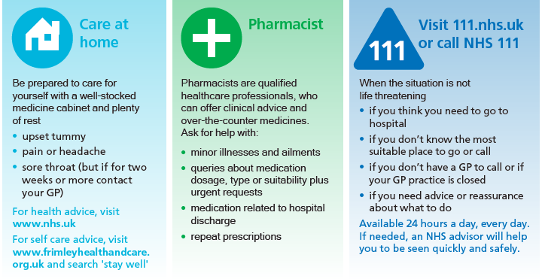

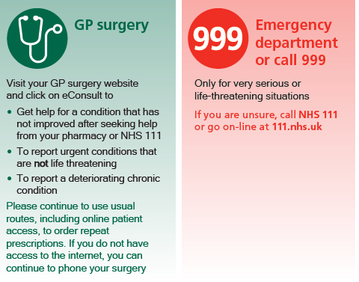

Thank you for your understanding and patience during these challenging times. If you have any concerns about your health we are here for you.

If you would like to contact a member of the Patient Participation Group to give feedback on this newsletter or any other feedback generally, please email Sally Hanson, Chair, Kings Corner Surgery Patient Participation Group. S.hanson737@btinternet.com

Wishing you a happy, safe and healthy summer season
The Team at Kings Corner Surgery
&
The Kings Corner Surgery Patient Participation Group

